**Advanced Database Management Systems**

**Experiment-4**

**Use of built-in functions and relational algebra operations.**

**Aryan Mohan**

**500092142**

**Batch- 2**

CREATE DATABASE Experiment4;

CREATE TABLE EMP (

EMPNO INT NOT NULL,

ENAME VARCHAR(20) NOT NULL,

JOB VARCHAR(20) NOT NULL,

MGR INT,

HIREDATE DATE NOT NULL,

SAL DECIMAL(10, 2),

COMM DECIMAL(10, 2),

DEPTNO INT NOT NULL,

PRIMARY KEY (EMPNO) );

INSERT INTO EMP VALUES

(7369, 'Smith', 'CLERK', 7902, '17-Dec-80', 500, 800, 20),

(7499, 'Allen', 'SALESMAN', 7698, '20-Feb-81', 1600, 300, 30),

(7521, 'Ward', 'SALESMAN', 7698, '22-Feb-81', 1250, 500, 30),

(7566, 'Jones', 'MANAGER', 7839, '2-Apr-81', 2975, NULL, 20),

(7654, 'Martin', 'SALESMAN', 7698, '28-Sep-81', 1250, 1400, 30),

(7698, 'Blake', 'MANAGER', 7839, '1-May-81', 2850, NULL, 30),

(7782, 'Clark', 'MANAGER', 7839, '9-June-81', 2450, NULL, 10),

(7788, 'Scott', 'ANALYST', 7566, '9-Dec-82', 3000, NULL, 20),

(7839, 'King', 'PRESIDENT', NULL, '17-Nov-81', 5000, NULL, 10),

(7844, 'Turner', 'SALESMAN', 7698, '8-Sep-81', 1500, 0, 30),

(7876, 'Adams', 'CLERK', 7788, '12-Jan-83', 1100, NULL, 20), (7900, 'James', 'CLERK', 7698, '3-Dec-81', 950, NULL, 30),

(7902, 'Ford', 'ANALYST', 7566, '3-Dec-81', 3000, NULL, 20),

(7934, 'Miller', 'CLERK', 7782, '23-Jan-82', 1300, NULL, 10);

SELECT * from EMP;

CREATE TABLE DEPT (

DEPTNO INT,

DNAME VARCHAR(20), LOC VARCHAR(30), PRIMARY KEY (DEPTNO)

);

INSERT INTO DEPT

VALUES

(10, 'ACCOUNTING', 'NEW YORK'),

(20, 'RESEARCH', 'DALLAS'),

(30, 'SALES', 'CHICAGO'),

(40, 'OPERATIONS', 'BOSTON');

ALTER TABLE EMP

ADD CONSTRAINT fk_deptno

FOREIGN KEY (DEPTNO)

REFERENCES DEPT (DEPTNO);

SELECT * from DEPT;

-- List the details of the emps whose salaries is more than employee Blake.

SELECT * from EMP

WHERE

SAL > (SELECT SAL from EMP where ENAME='Blake');

Output:

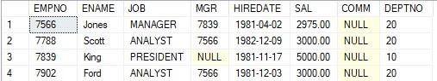

-- List the emps whose jobs are the same as Allen.

SELECT * from EMP

WHERE

JOB = (SELECT JOB from EMP where ENAME='Allen');

Output:

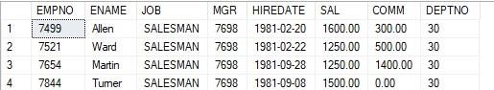

-- List the emps whose salaries is the same as Ford or Smith in descending order of names.

SELECT * from EMP

WHERE SAL = (SELECT SAL from EMP where ENAME='Ford') OR

SAL = (SELECT SAL from EMP where ENAME='Smith')

ORDER BY ENAME DESC;

Output:

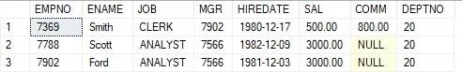

-- List the emps whose jobs are the same as Miller or salary is more than Allen.

SELECT * FROM EMP

WHERE JOB = (SELECT JOB FROM EMP WHERE ENAME='Miller') OR

SAL > (SELECT SAL FROM EMP WHERE ENAME='Allen');

Output:

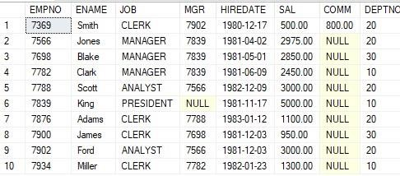

-- Find the highest paid employee in the Sales dept.

SELECT *

FROM EMP

WHERE DEPTNO = 30 AND SAL = (SELECT MAX(SAL) FROM EMP WHERE DEPTNO = 30);

Output:



-- List the employees who are senior to most recently higher employee working under King.

SELECT * FROM EMP

WHERE HIREDATE < (SELECT MAX(HIREDATE)

FROM EMP

WHERE MGR = (SELECT EMPNO FROM EMP WHERE ENAME='King'));

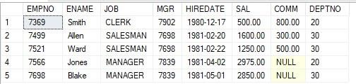Output:

-- List the names of employees who are getting the highest salary departmentwise.

SELECT E.ENAME, D.DNAME, E.SAL

FROM EMP E

JOIN DEPT D ON E.DEPTNO = D.DEPTNO

WHERE E.SAL = (SELECT MAX(SAL) FROM EMP WHERE DEPTNO = E.DEPTNO)

GROUP BY E.ENAME, D.DNAME, E.SAL

ORDER BY D.DNAME;

Output:

-- Alternate solution

SELECT ENAME, SAL, JOB

FROM EMP

WHERE DEPTNO = 10 AND SAL = (SELECT MAX(SAL) FROM EMP WHERE DEPTNO = 10) OR

DEPTNO = 20 AND SAL = (SELECT MAX(SAL) FROM EMP WHERE DEPTNO = 20) OR

DEPTNO = 30 AND SAL = (SELECT MAX(SAL) FROM EMP WHERE DEPTNO = 30)

OR

DEPTNO = 40 AND SAL = (SELECT MAX(SAL) FROM EMP WHERE DEPTNO = 40);

Output:

-- List all the employees whose sal is equal to the average of max and minimum.

SELECT * FROM EMP

WHERE SAL = (SELECT SAL = (MAX(SAL) + MIN(SAL))/2 FROM EMP);

Output:

-- List the emps who joined in the company on the same date.

SELECT ENAME, HIREDATE

FROM EMP

GROUP BY HIREDATE, ENAME

HAVING COUNT(*) > 1;

Output:

-- Alternate solution

SELECT ENAME, HIREDATE

FROM EMP

WHERE HIREDATE in (SELECT HIREDATE FROM EMP WHERE EMPNO <> EMPNO);

Output:

-- List the employees who joined the company before their managers.

SELECT * FROM EMP E

WHERE HIREDATE < (SELECT HIREDATE FROM EMP WHERE EMPNO = E.MGR);

Output:

Query 1:

Query 2:

Query 3:

Query 4:

Query 5:

Query

6:

Query 7:

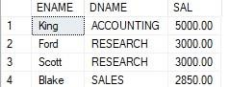

Query 8:



Query 9:

Query 10:

